Cody’s Pong

Let’s document cases where stuffup occurs.

Disable the screen redraw so we can see where ball goes.

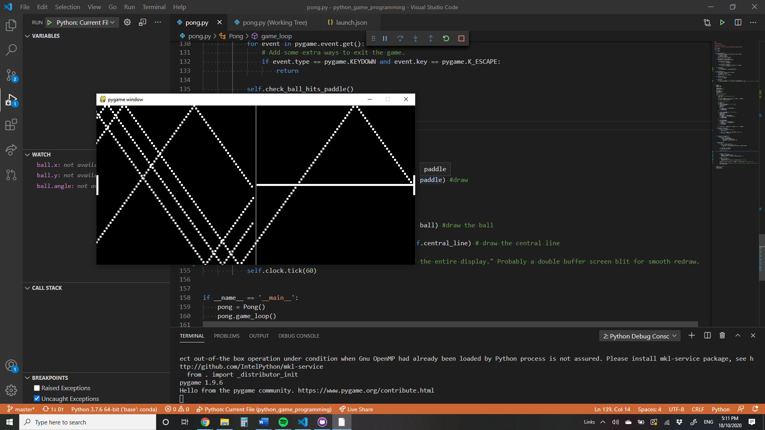



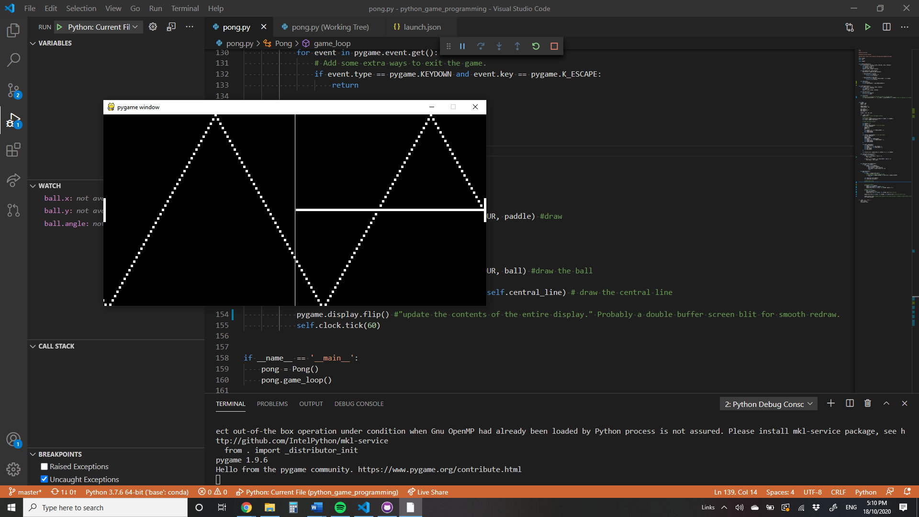



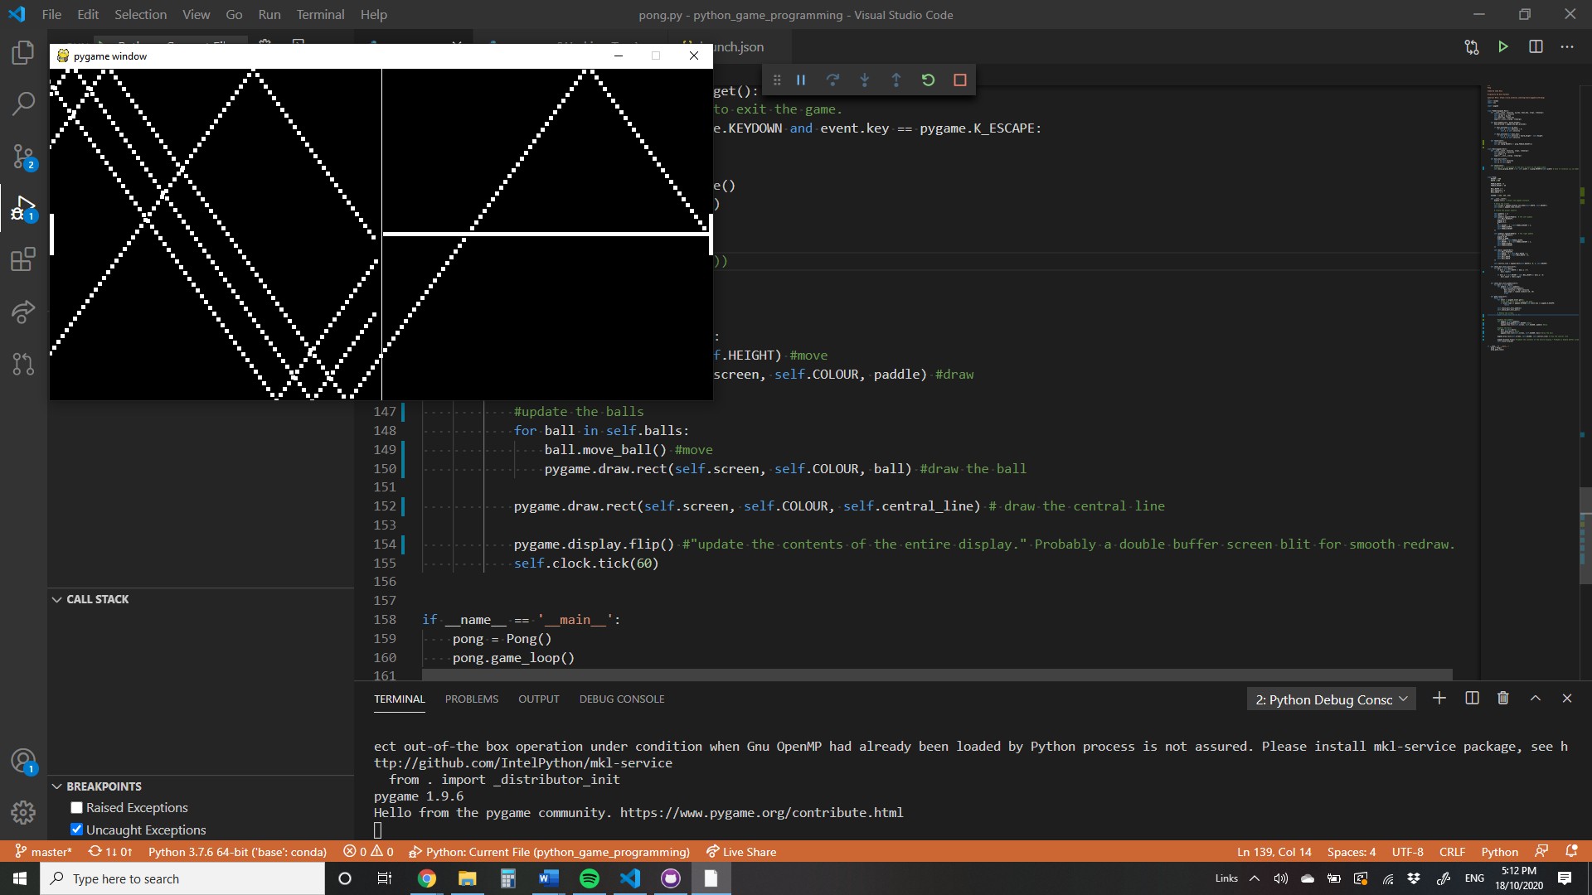



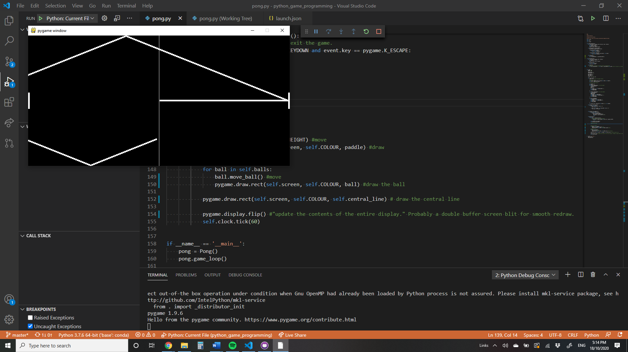



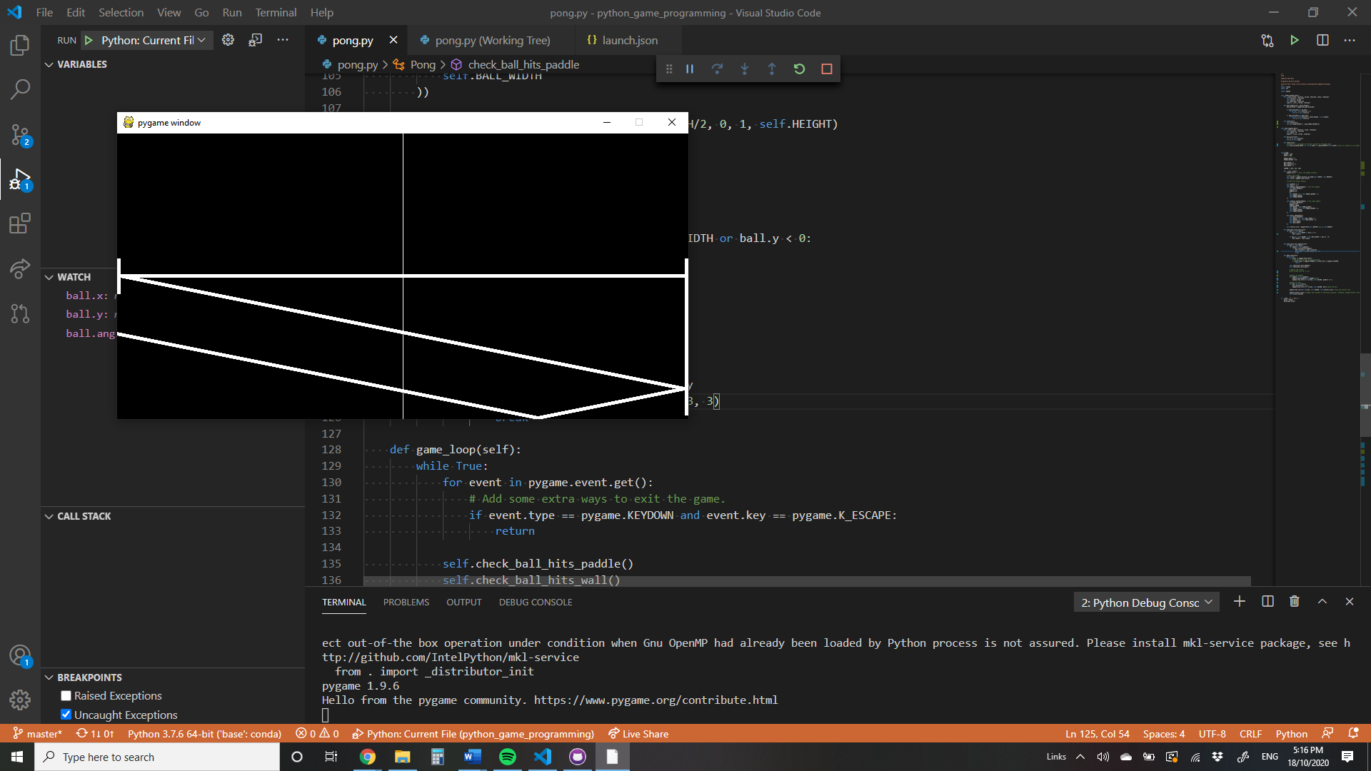



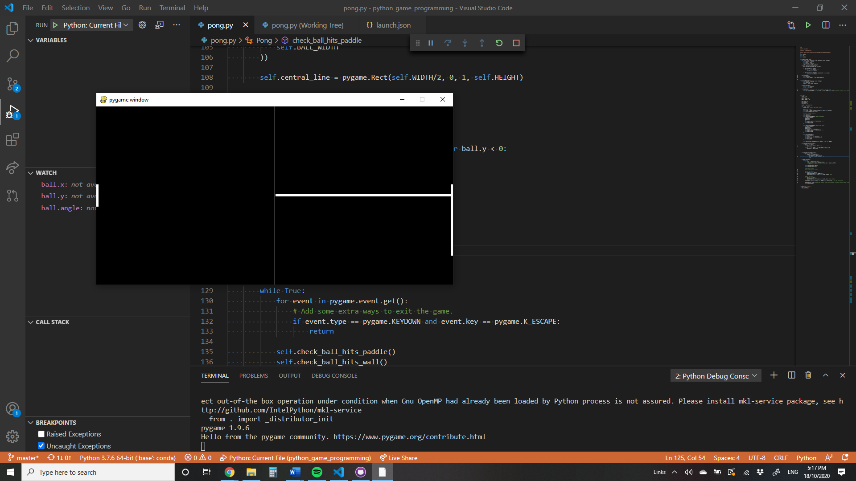



Finally we see problem is not isolated to lower left corner of screen.

Redraw paddles but not the ball for further debugging

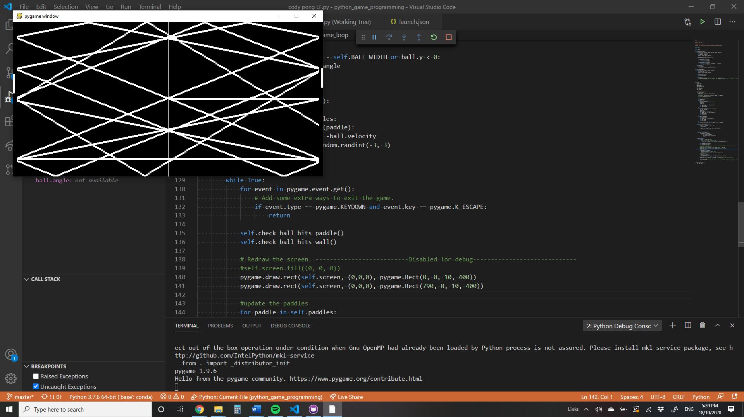



From this we see that there’s no problem with bouncing on paddles.

Problem must be in vertical walls.

No problem there

So next is the reset() function

We used move in place

Not the correct function – looking at discussions on the net – all move functions in pygame are incremental and do not go to a location.

So we need to edit the location variables directly.

They are Left and Top